

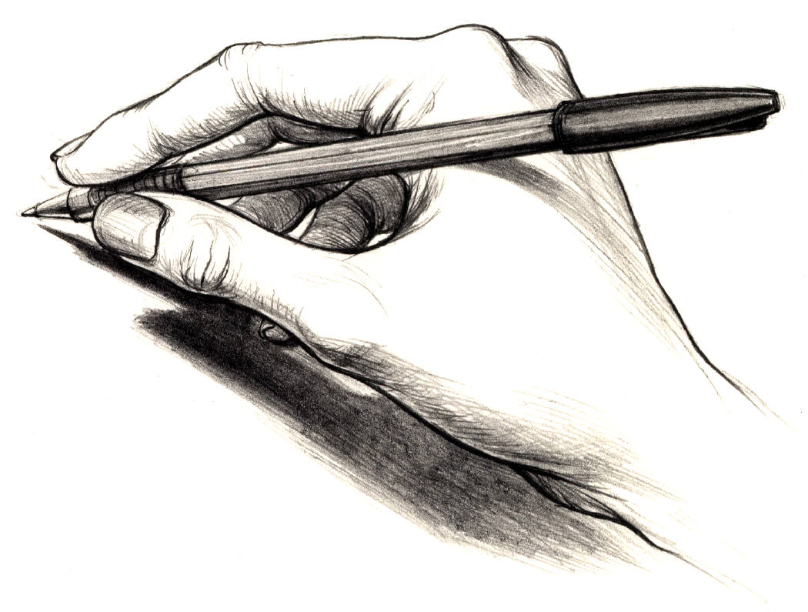



Copyright Regulations 1969
WARNING
This material has been reproduced and communicated to you by or on behalf of
Distance Education Tasmania pursuant to Part VB of the Copyright Act 1968 (The Act).
The material in this communication may be subject to copyright under the Act.
Any further reproduction or communication of this material by you
may be the subject of copyright protection under the Act.
Do not remove this notice.
This material has been produced by Distance Education Tasmania.
Its content has been authorised by the Principal.
Questions concerning its content may be directed by email to
distance.education.tasmania@education.tas.gov.au

Acknowledgement
Basic Handwriting, Education Department, Tasmania, Australia. 1985

Information for Parents
Handwriting

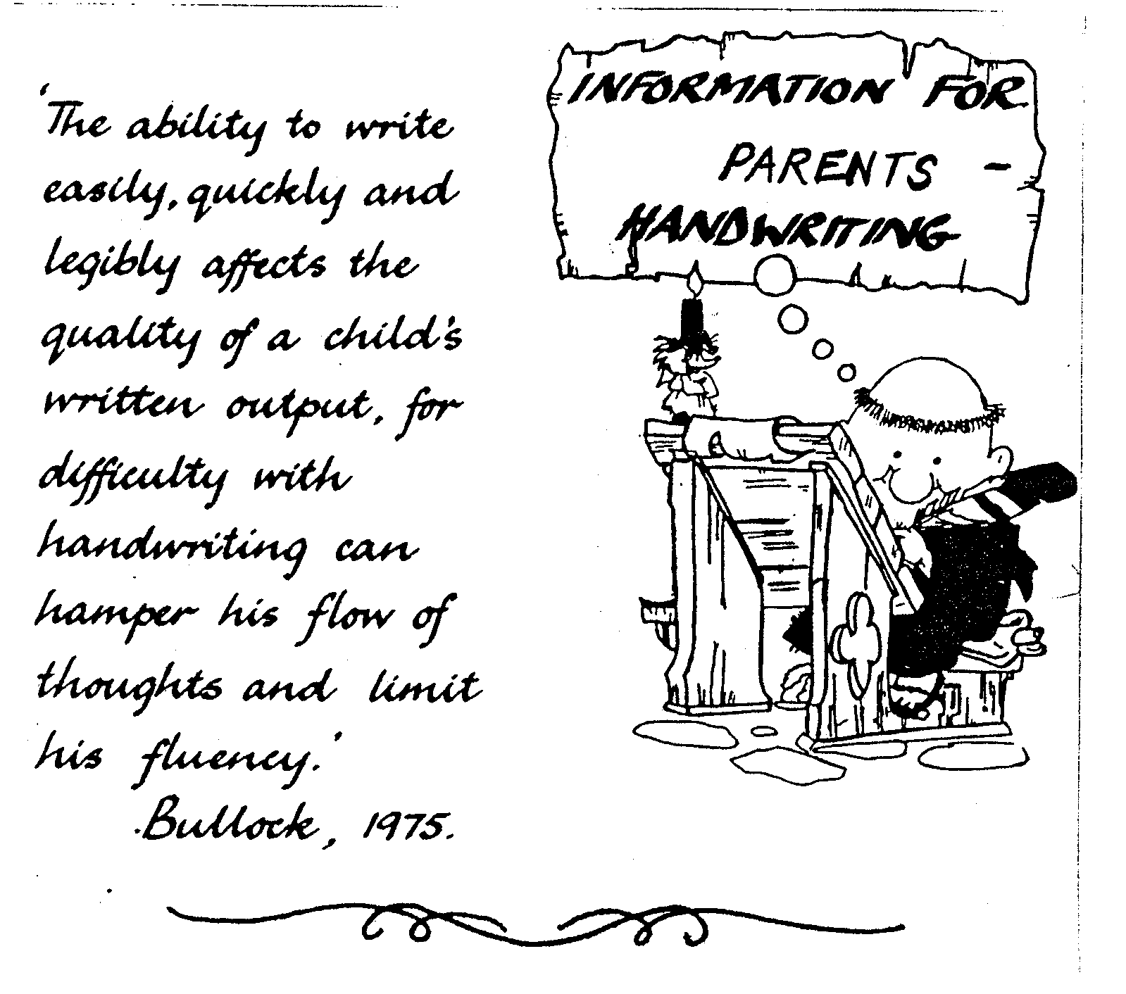

Inside this booklet is information to assist you as you help your child with handwriting.

The notes have been grouped for easy reference. You may wish to browse through all of these notes and then select what is most useful to you at any particular time.

The exercise sheets included for your child should not be attempted too quickly. Some children may become interested and wish to practise more often than others, which is why several exercises have been included. It would be useful for the child to have at least three practise sessions each week, but the time spent will always vary according to interest and involvement in other activities.

Please contact your child’s teacher if you have any queries at any time. Good luck!
INTRODUCING THE LETTER AND NUMERAL FORMATIONS

Each formation is shown in detail on the following pages. Letter combinations and words for practising the formation are given as suggestions only.

LOWER CASE

Letters may be grouped for teaching purposes according to direction as follows:

Letters with anticlockwise emphasis:

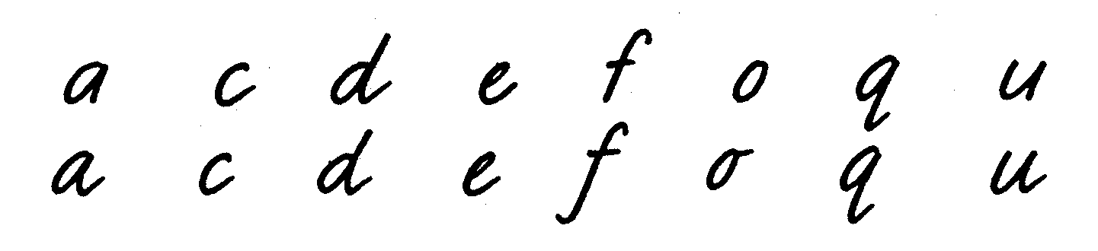

Letters with clockwise emphasis:

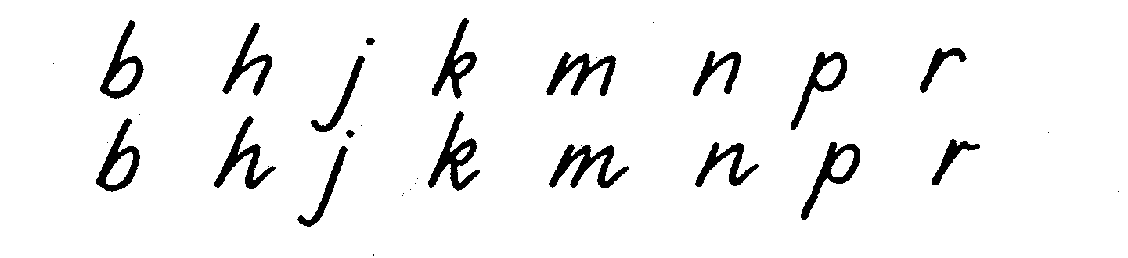

Letters incorporating both clockwise and anticlockwise movements:

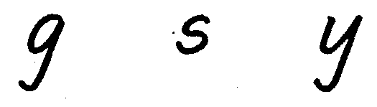

Linear movement:

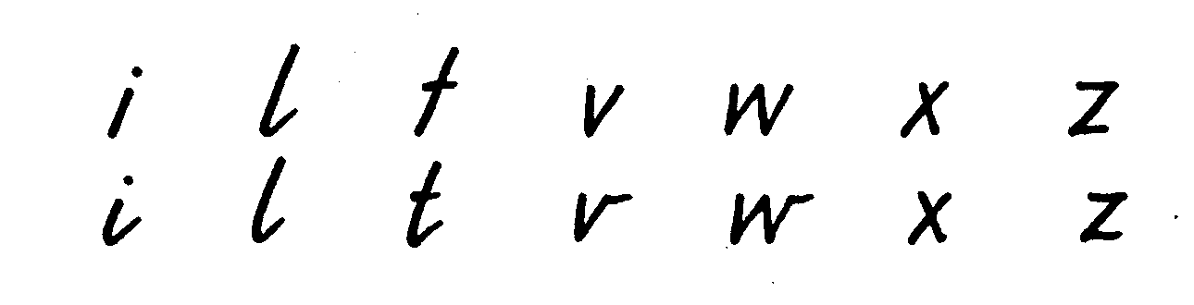
CAPITALS

One-stroke:

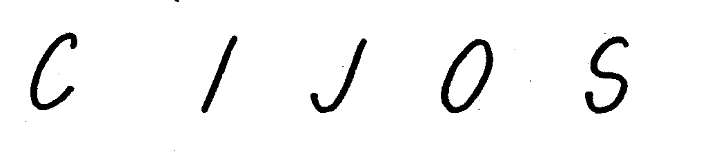

Two-stroke:



Three-stroke:

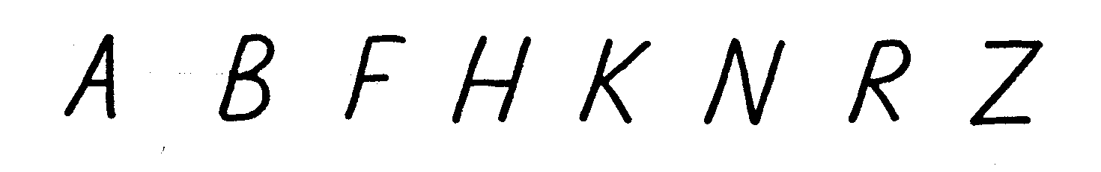

Four-stroke:



Numerals

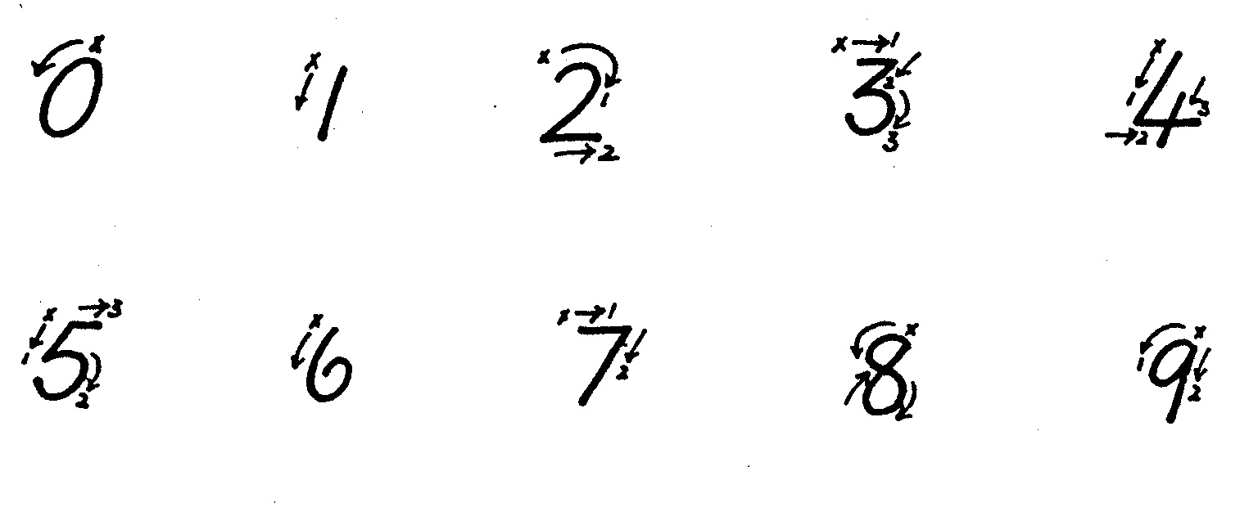
INTRODUCTORY NOTES

GUIDE FOR HOME HELPERS OF DISTANCE EDUCATION STUDENTS

Handwriting is a basic skill, a tool for expression and communication.

Legible handwriting is also a requirement for many occupations. It is essential that your child develops a style of handwriting that is easily read and easily written.

Through the handwriting program your child should:
- become aware that:
  - print conveys a message
  - handwriting is a tool used in the writing process

- .develop:
  - a positive attitude towards themselves and their handwriting
  - the desire to develop a personal style

The materials have been designed to help you in providing support and encouragement for your child and their handwriting. If at any time you, or your child, experience difficulties please do not hesitate to contact your child's teacher.

ENCOURAGING HIGH STANDARDS

The following suggested activities will direct your child's attention to the need for handwriting of a high standard:
- writing letters to penfriends, relatives, teachers
- addressing envelopes
- notes to parents
- invitations, e.g. birthday parties
- greeting cards for special occasions
- practising signatures and initials
- publishing - verse and prose, proverbs, family newsletters, recipes, menus, favourite book reviews
- experimentation with variety of instruments and materials
- designing decorative titles and borders

It may also assist to build up some of the following materials for your child's use:
- paper in a variety of sizes, colours, qualities, both lined and unlined
- a variety of pens, pencils, crayons, textas, brushes, inks
- scissors, paste, pins, tape, rulers, glitter

These materials could be stored in a cardboard box labelled "Writing Materials". Your child may wish to decorate the box by painting, drawing or cutting up old colourful magazines and pasting pictures on.
THE LEFT-HANDED WRITER

The following suggestions may be helpful.

The truly left-handed child must be allowed to write with this hand.

The left-handed writer may experience difficulties unknown to the right-handed child. However, with careful instruction, the left-handed child should learn to write with considerable fluency.

Some problems which may be experienced are:
- Free writing movements may be restricted as the writing arm moves towards and across the body rather than moving away.
- What is being written is hidden and as the hand passes over the writing, smudging may occur. It is also difficult to write fluently when what is being written is partially covered.
- Writing from left to right is against the natural movement of the left-handed writer. The writing instrument must be pushed rather than pulled across the paper.
- Demonstration by a right-handed adult is often confusing.

These suggestions may help to minimise difficulties:

- Pencil hold - The pencil should be held slightly farther from the point than is usual to enable the child to better see what is being written.
- Paper position - The paper should be placed slightly to the left of the writer and tilted to the right.
- Slope - A more upright slope may be more practical.
- Body position - The body may be turned slightly to the right to allow the left arm greater freedom of movement.
- Lighting - Hand and arm should not exclude light. Ideally, light should come from behind and over the right shoulder.
- Seating - The left-handed writer should be placed to the left of a right-handed writer to avoid restriction of arm movement.

PRELIMINARY STAGE

Before any handwriting instruction begins your child will need to have developed certain skills. Most of these skills will have developed naturally during early childhood years.

The following activities can be used to assist the development of manipulation skills which are necessary before any formal handwriting instruction begins. Motor control, hand/eye co-ordinator, muscular control, and visual memory, are all skills that need to be developed.

Concepts such as left, right, top, bottom, up, down, over, under, above, in, out, size, shape, beside, below, high, low, between, before, after, next, start, finish, big and little will also need to be developed.

Some activities that will aid the development of these skills and concepts are:
- finger painting
- painting with a brush
- drawing - pencil, felt pen, crayon
- measuring and pouring water
- screwing and unscrewing jar tops
- modelling in sand, clay, play-dough
- tearing and folding paper
- block building
- constructing toys
- pasting
- cutting
- pattern - making
- jig-saws
- sorting - objects, shapes
- matching - objects, shapes, pictures, words, letters
- finding differences - objects, shapes, pictures, words, letters
- threading
- sewing. lacing, buttoning, buckling, tying laces

BEGINNERS STAGE

From the very beginning attention must be given to:
- sitting position
- pen/pencil hold
- hand and arm movements

The following may help you to assist your child to master these important techniques.

RELAXATION

Relaxed muscles assist in developing rhythmic and fluent writing movements. These exercises should assist:
- clenching and unclenching hands
- drumming fingers lightly on the desk or table
- shaking the hands from the wrist
- moving the hands in a circular motion from the wrist
- reaching arms above the head

SLOPE

THE SLOPE OF THE WRITING STYLE IS PRODUCED BY
TILTING THE PAPER, NOT BY SLOPING THE WRITING

Slope achieved other than by tilting the paper affects the writing technique, for example, leaning sideways or twisting the body and restricting hand and arm movements.

For right-handers the paper is tilted to the left at an angle of approximately 20⁰. (See diagram below.) For most children this paper position will be automatically adopted.

The paper tilt may vary for some left-handers, depending on the position of their hand in relation to what is being written. Very often the paper will be tilted to the right and in some cases it will be in a fairly straight position.

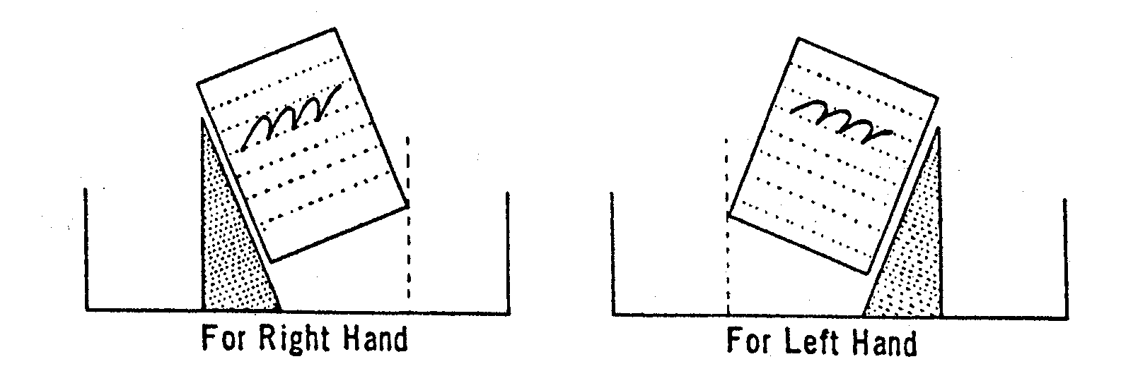

HOW TO SIT

Body Balance
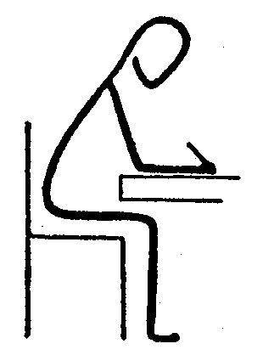

- Lean forward a little but do not lean on the, desk or table

- Do not lean sideways or twist the body

- The head should not be too near the paper

- The feet should be on the floor

- The elbows should be near the edge of the desk and the arms should be spread out away from the body

- Do not sit stiffly. A comfortable position is necessary so that the hand and arm can move freely

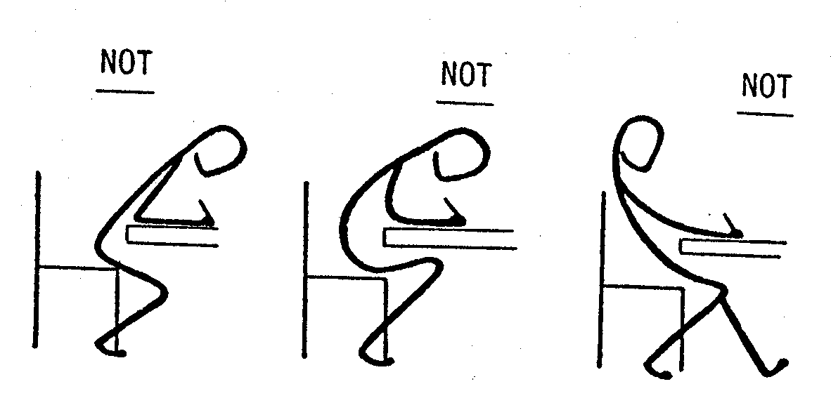
PRELIMINARY WRITING PATTERNS

The usefulness of patterns is that they provide an opportunity to practise basic handwriting movements. The development of the basic movements, particularly the oval, parallel strokes and horizontal strokes is essential. Writing patterns have been designed to help children to:
- gain control of the implement and develop 'eye-control' by co-ordinating hand and eye;
- learn directional segments and movements such as top and
- bottom, left to right, clockwise and anticlockwise rotation;
- develop rhythmic movements.

It is important that you work with your child so that the child can model your movements. Your child's efforts will improve with encouragement, experience and practice. Exercises are best practised on blank paper to avoid restricted movements. Each pattern could be continued across a large sheet of paper (old newspapers?) until written confidently and fluently. The child should be encouraged to increase the speed and fluency of the pattern-making. Any combinations of exercises may be asked. The time spent on these exercises in any one session will depend on the child's interest and you should expect this to vary. The child can be encouraged to copy the patterns found in natural objects such as shells, stones and leaves. Children can also be encouraged to design their own patterns.

Jingles and nursery rhymes are one way of stimulating children to make their own patterns as they provide natural rhythms which assist children in developing smooth, rhythmical movements in writing, particularly in pattern-making exercises.

SUGGESTED METHODS FOR HOLDING THE PENCIL

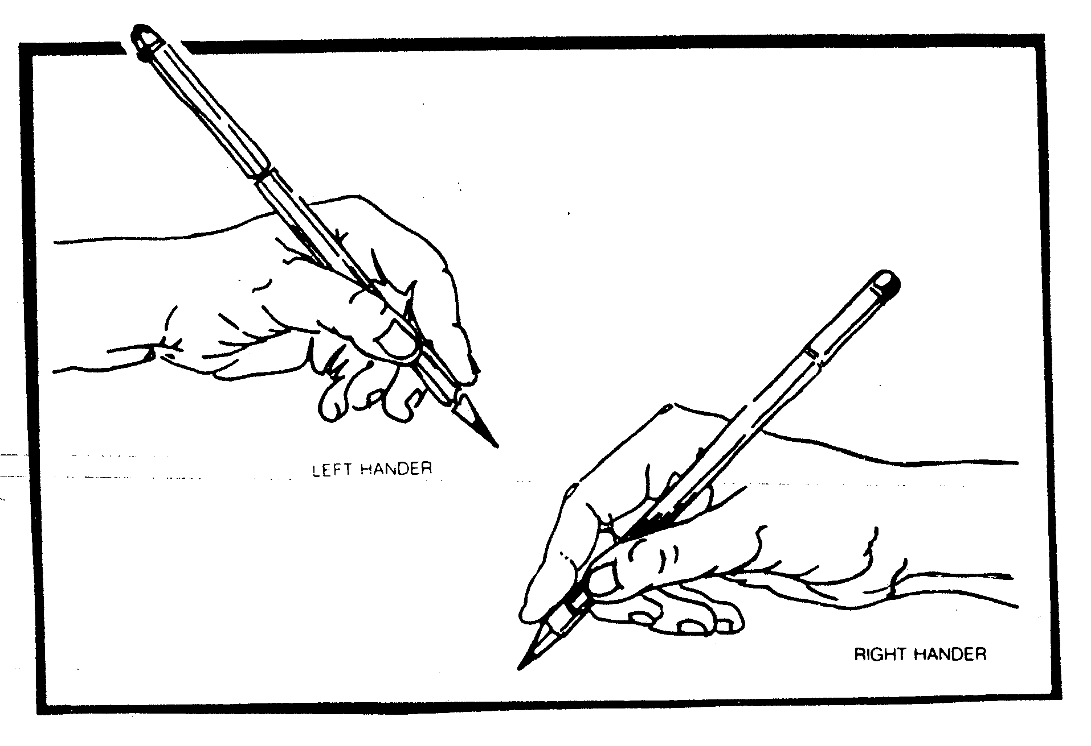

Pen and Pencil hold

- The pencil should be held between the second finger and the thumb. The first finger should rest lightly on the pencil.
- The barrel of the pencil should rest against the knuckle at the base of the first finger, pointing outwards above the elbow.
- The pencil should be held about two centimetres from the paper - a little higher for left-handers.
- The side of the forearm and the third and little fingers should lightly touch the paper.

Playing hand-clapping games with your child will also assist in developing co-ordination and rhythm.

Your child needs to have plenty of opportunities to develop the following, before handwriting instruction can begin:

Visual discrimination -recognising fine differences
- home-made games
- matching games, e.g. 'snap', dominoes
- recognising the 'odd one out' in a sequence
- finding hidden objects in pictures, environmental materials

Visual memory -remembering a shape and then reproducing it from memory
- memory games - objects are shown then covered - an attempt is made to recall the items
- reproducing; after a brief exposure to the original, a sequence of shapes, objects, letters, colours
The following suggested exercises use the basic stroke patterns.

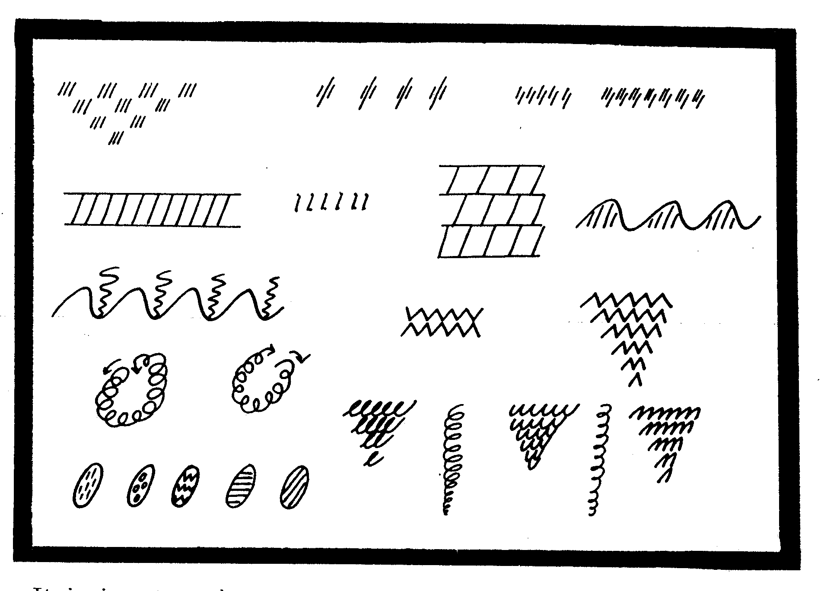

It is important that you give oral clues to the child, e.g. 'start at the top', 'go down', 'go this way'. Show them, talk to them and have them practise the movement with you before they attempt to use pencil or crayon to produce the pattern on paper.

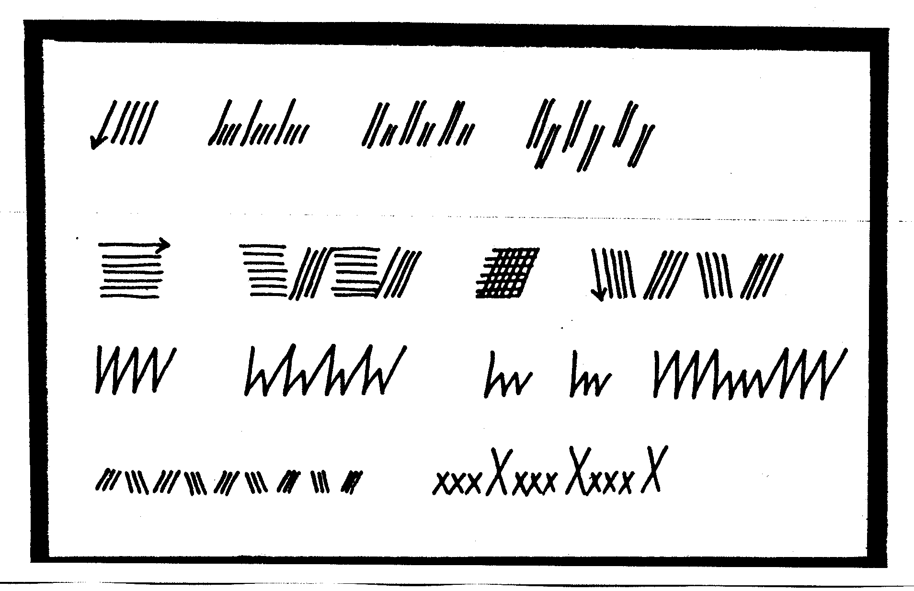
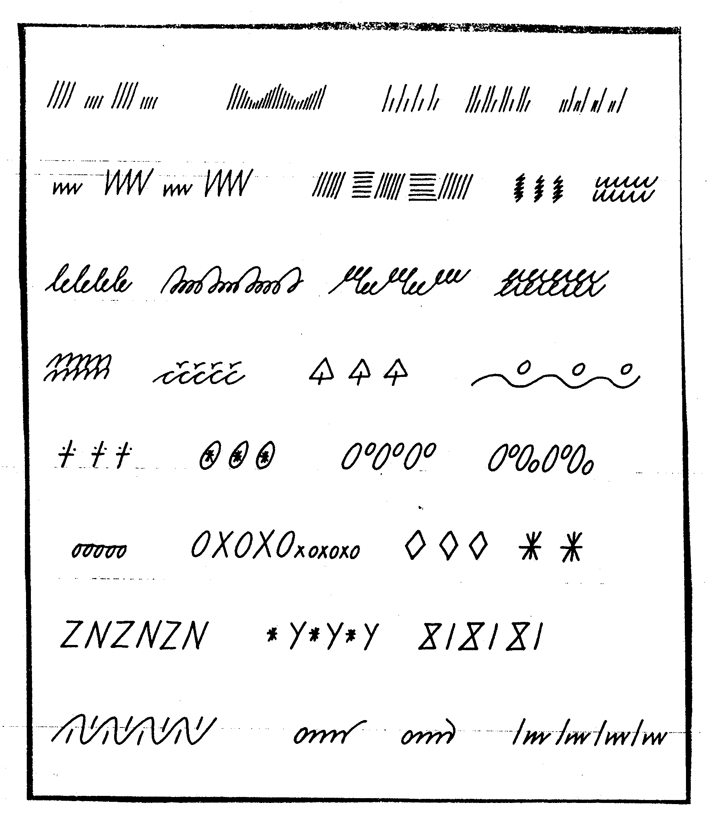
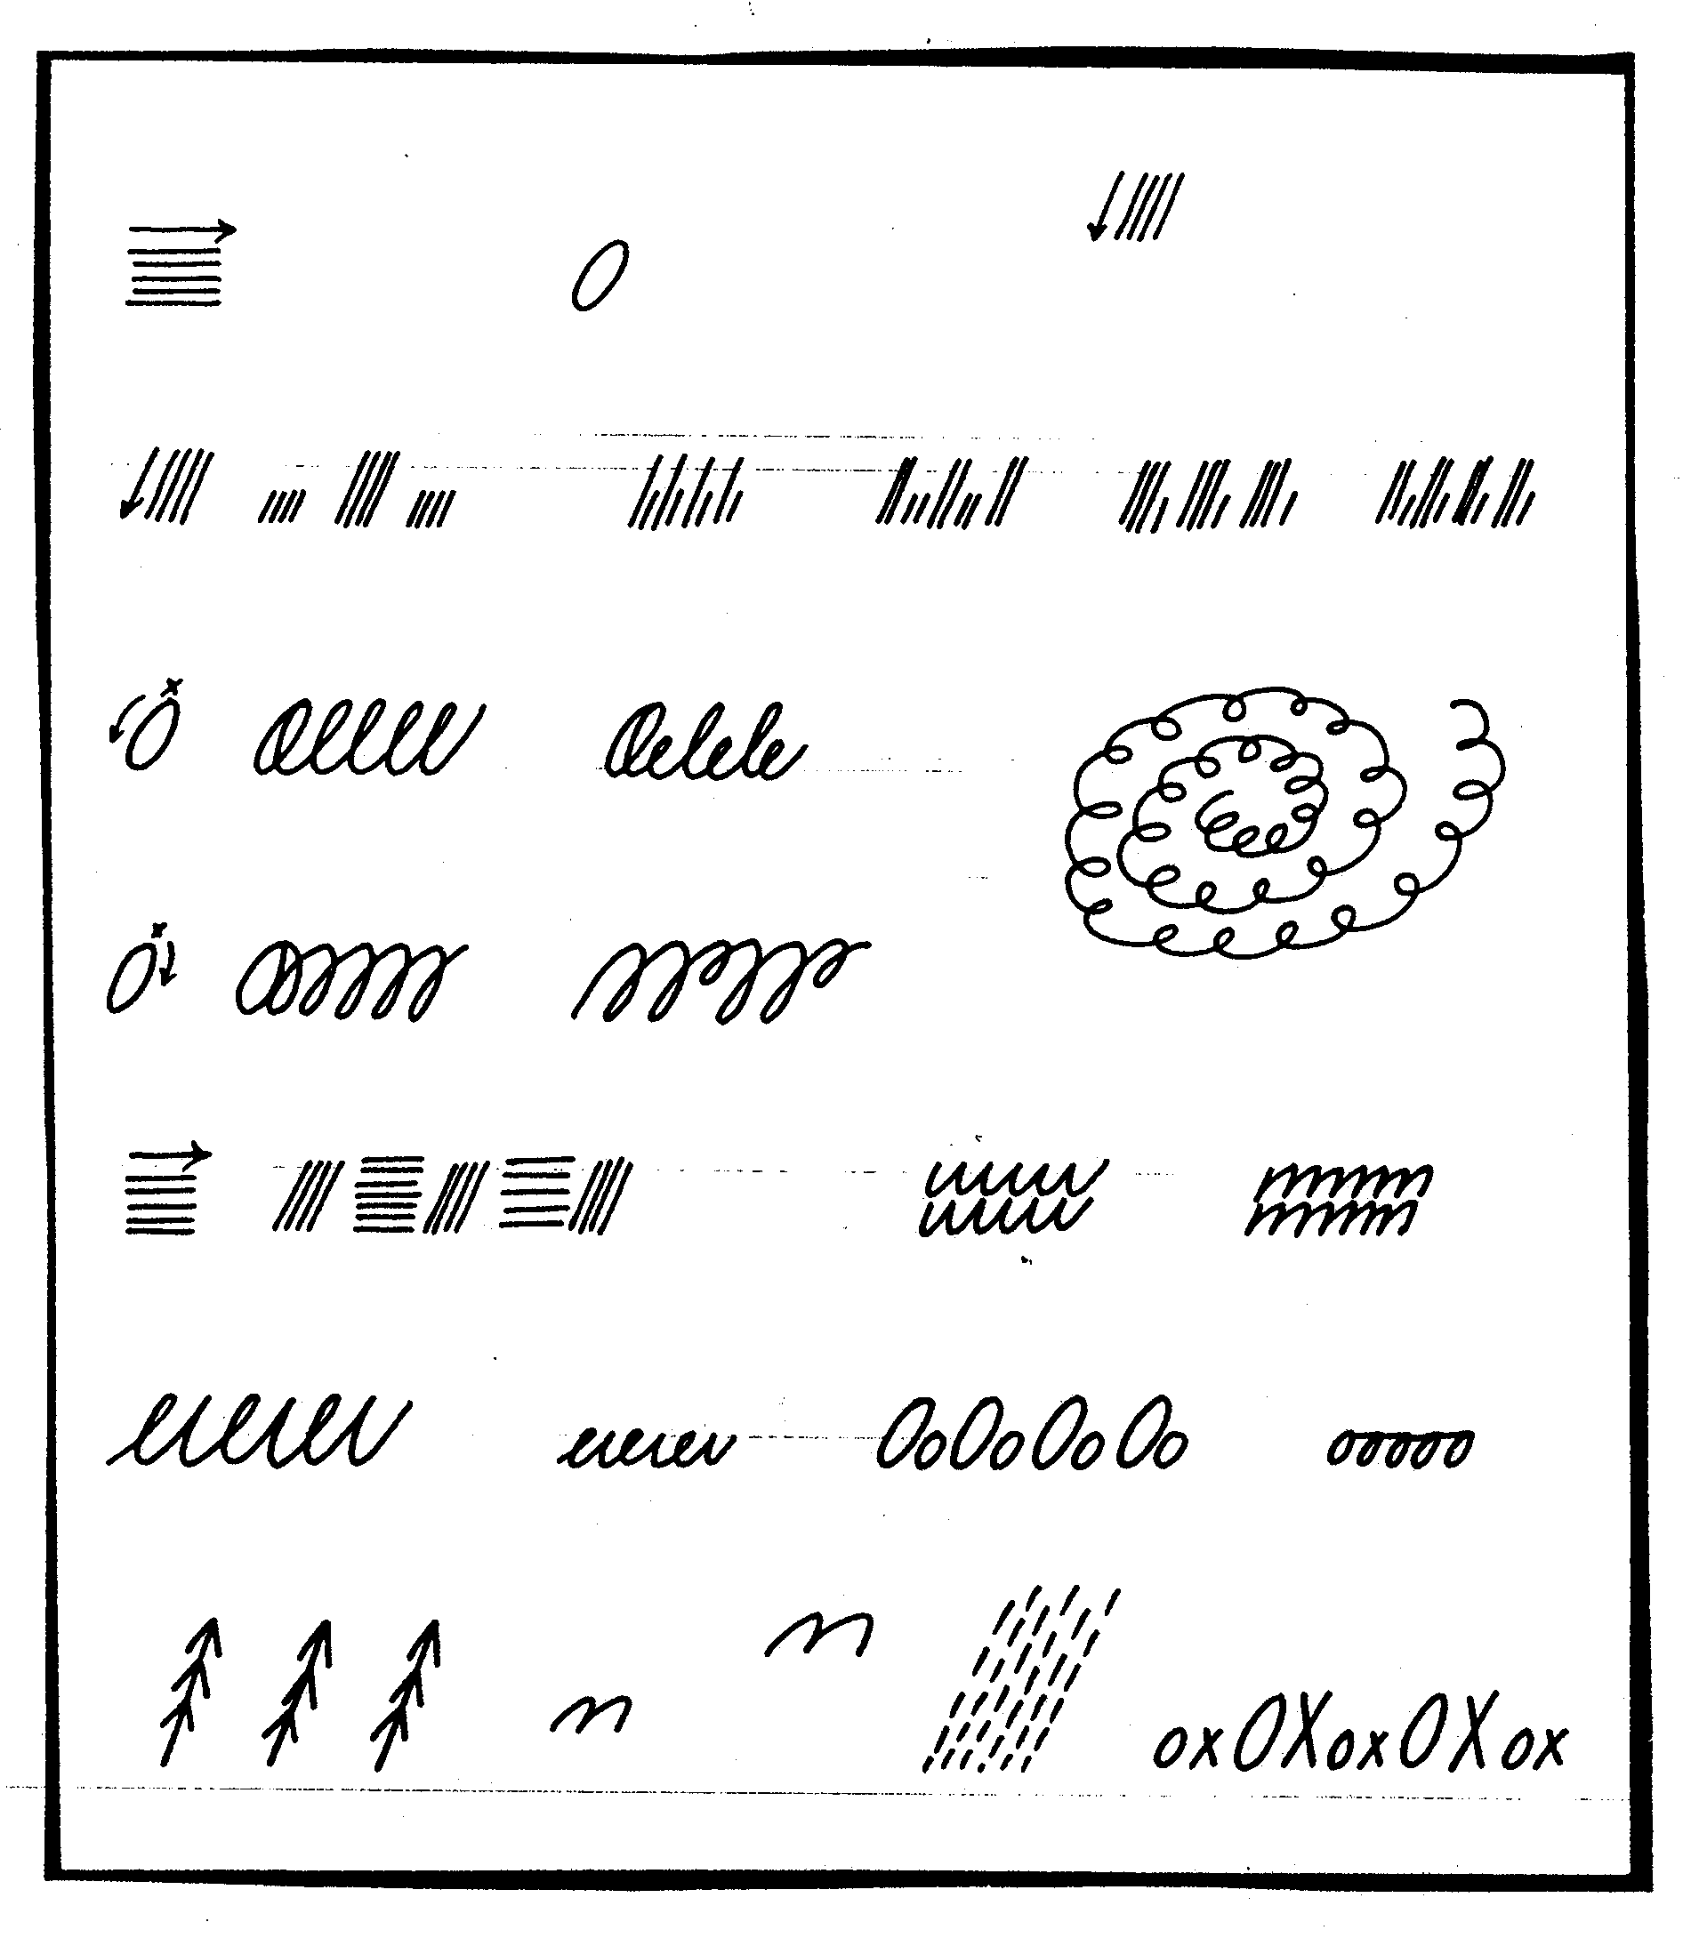
THE CURSIVE STAGE
This stage involves the joining of letters

As children become confident with writing letter shapes of the Beginner's Alphabet, joining letters will be introduced to develop the Cursive style.

Joins are produced by adding an upward movement from one letter to the next. However, not all letters join because of directional movements involved. Letters should always be grouped, for teaching purposes, according to direction, as follows: (Beginner's Alphabet shown first with Cursive Alphabet below)

Letters with anticlockwise emphasis:

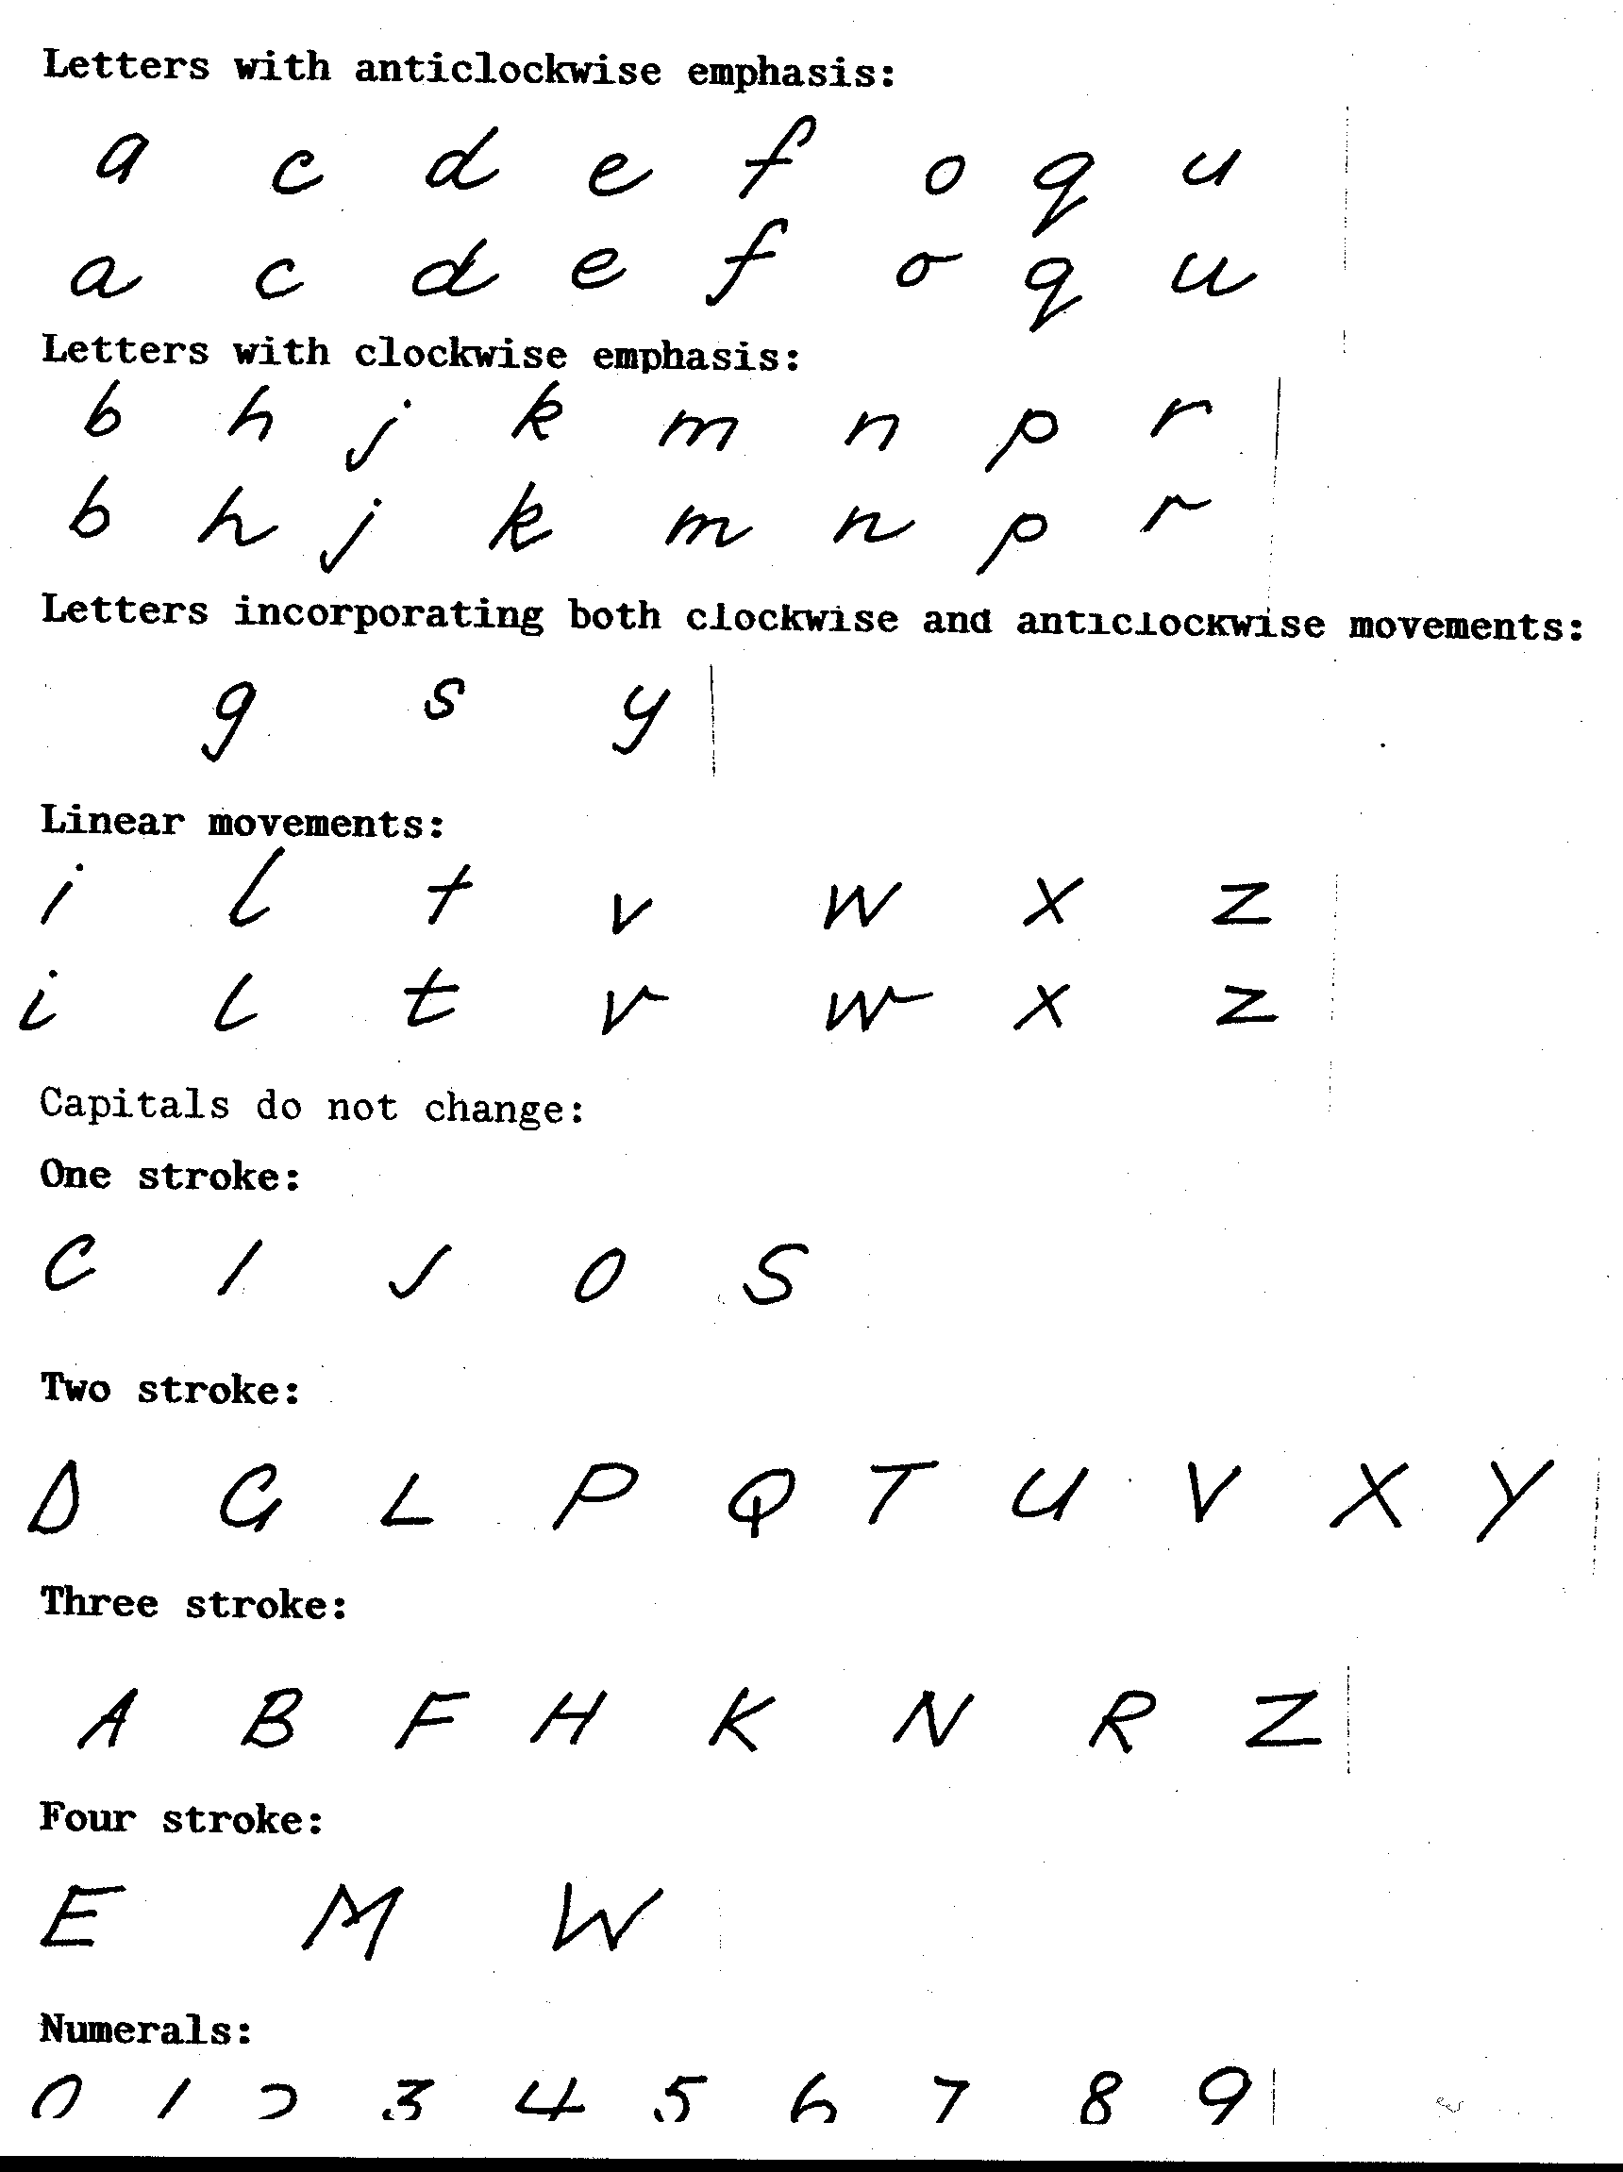
LETTER CONNECTIONS: REFERENCE FOR HOME HELPERS

Some letters are not connected to the letters that follow and some combinations do not appear in our language.

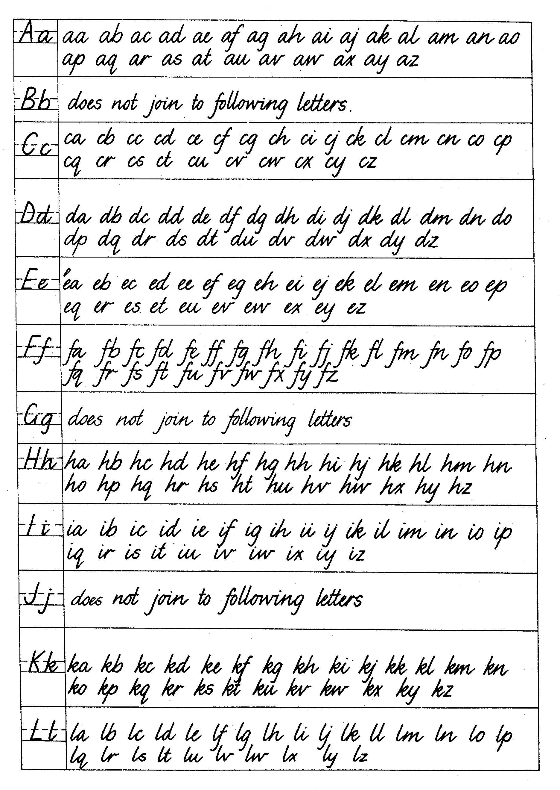

Letter connections (continued)
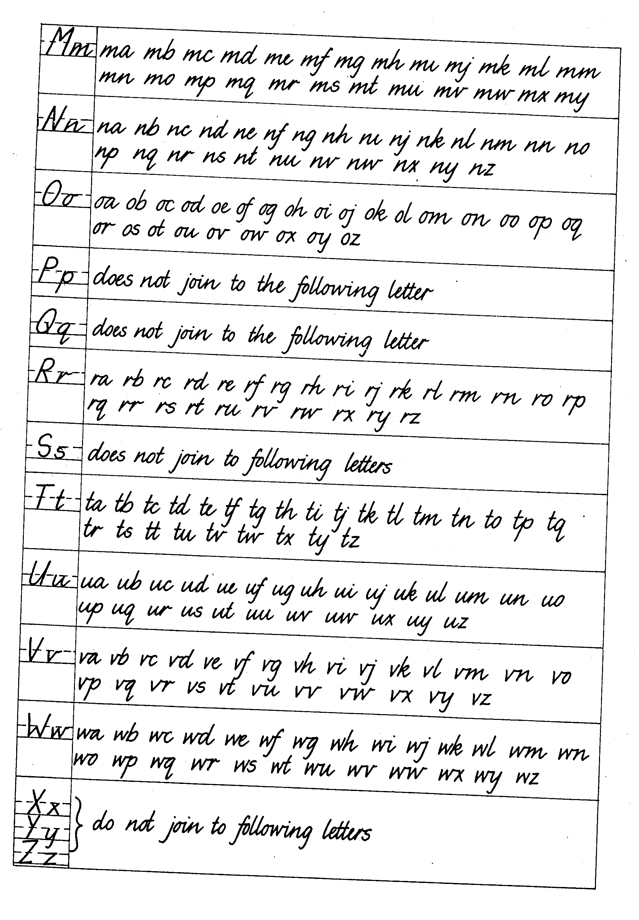

DEVELOPING A PERSONAL STYLE

DEVELOPING AN INDIVIDUAL STYLE

The fundamental purpose of the basic style of handwriting is to assist students to develop individual, personal styles that are legible and fluent.

Children, like adults, inevitably develop a personal style of handwriting. This style will be influenced by the curriculum model, but will not simply be a reproduction of the model. The curriculum model is only a 'foundation'.

As children develop confidence in writing and handwriting, they will naturally begin to express their personal preferences for appearance and in doing so will make modifications to the basic letter shapes. As
speed increases, sharp corners may be rounded (e.g. 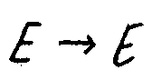);
speed loops and other joining lines may appear (e.g. 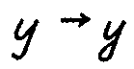); and
changes in stroking direction may occur (e.g.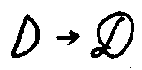)

Children at this stage of handwriting development are chiefly influenced by:
- the purpose for which the handwriting is being used;
- the mental and physical conditions of the writer (which produce temporary variations as well as permanent ones).

Another strong influence, especially during adolescence, is the handwriting of relations or friends. Children who do not have the ability or desire to elaborate the basic style should not be expected to do so.

Some modifications may appear at this stage:
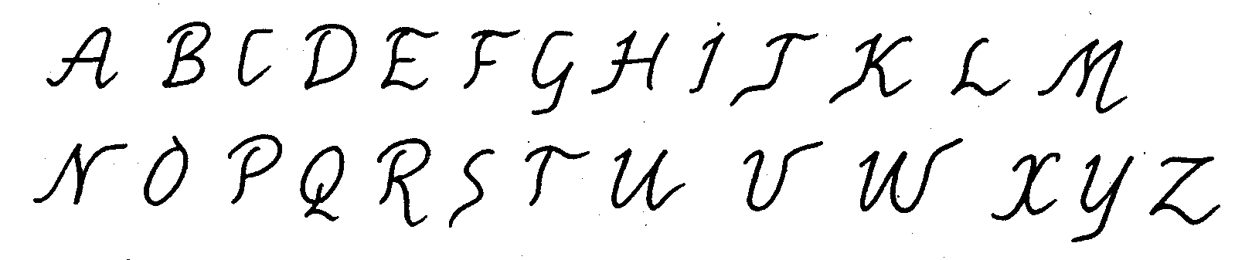
Any such modifications should be accepted, provided that the fundamental requirements of legibility and fluency are preserved.

In the upper primary years flourished capitals can be taught as children develop skill and interest in different forms of handwriting.
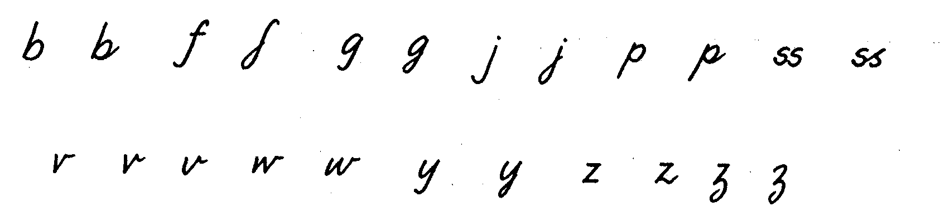

At all stages it is a good idea to talk with your child about the progress being made.

Try to remember that we all learn at different rates. Sometimes you will see considerable progress. Encourage your child by talking about any obvious progress and be sure to praise the effort.

At other times there may be no apparent progress. This is most probably a consolidation stage, which is to be expected.

Regular attention to techniques is important: pencil-hold, seating position, paper position.

It is extremely important that any problems encountered by you, or your child, receive help as soon as possible. For this reason, please contact your child's teacher as soon as any difficulty is experienced.

It is equally important to contact your child's teacher when any positive achievement is noted!
CHECKING PROGRESS

The following checklists may help you in checking your child’s progress. Use only the columns you feel are appropriate. Maybe going through the checklist once a month would be useful for you in checking your child’s progress, with specifics to discuss with your child. Your child may wish to help you with completing the checklist occasionally. This would certainly make them more aware of factors that affect legible handwriting and also provide a motivation to improve.

CHECKLIST FOR …………………………….’S HANDWRITING PROGRESS DATE: ……………………………
Month | Pencil hold  Sitting position | a c d e f o q u | b h j k m n p r | g s y | I l t v w x z | Capital letters | Size | Spacing –  - within words  - between words | Joining – if at the cursive stage | Margins and arrangement | Slope | General
February
March
April
May
June
July
August
September
November

